**Experiment No. 1.2**

**Student Name: Rishav Kumar UID: 22MCC20039**

**Branch: MCA - CCD Section/Group: MCD-1/ Grp B**

**Semester: I Date of Performance: 6th Nov 22**

**Subject Name: Linux Administration Lab Subject Code: 22CAP-648**

1. **Task to be done:**

Write a command used to display existing partitions and sizes using 2 different commands. After than compare the outputs of both. After this create a new 400MB primary partition and 2 extended partition under that primary partition and check whether both partitions are created or not.

1. **Code for experiment/practical:**

* Command to display existing partitions

1. *Lsblk*
2. *Fdisk -l*

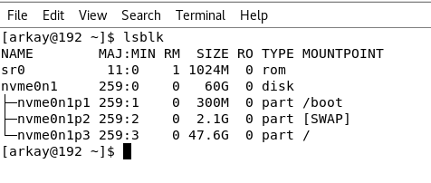

* Switch to Root user to create partition using ***su root***
* Use this command and press n to create new partition.

*fdisk /dev/nvme0n1*

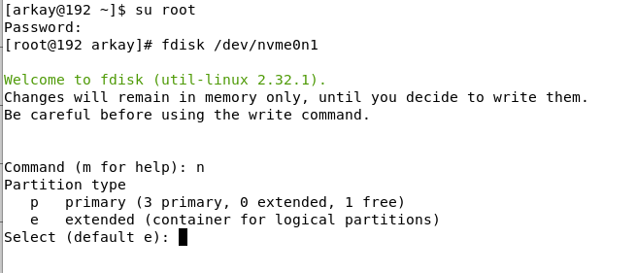

* Click Enter (*It will select default e for logical partition*)
* Leave the First sector blank and press enter.
* Enter the value like ***+400M*** to create a new partition of 400MB.
* Enter ***w*** to save.
* Check the partitions using ***lsblk*** command.

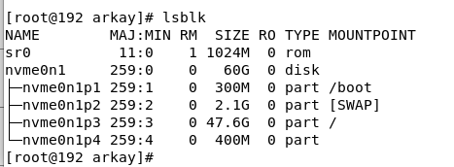

**Learning outcomes (What I have learned):**

1. **Learned about checking partitions in Linux.**
2. **Learned about creating a partition in Linux.**

**************************************** **THE END** ***********************************************